**NATIONAL INSTITUTE OF TECHNOLOGY KARNATAKA, SURATHKAL**



**Project Report**

On

**CITIZEN DATABASE MANAGEMENT**

*Submitted in partial fulfillment of the requirements*

*for the completion of the course*

**CO305 DATABASE SYSTEMS LAB**

*Submitted By*

Rabindra C 11CO70

Radheshyam Verma 11CO71

Rahul Das 11CO72

Rahul Bhojwani 11CO73

*Under the guidance of*

Dr. Ravindranath C

November 2013

**CONTENTS**

1. **Declaration..........................................................................................................................3**

2. **Acknowledgements............................................................................................................4**

3. **Introduction………………………………………………………………………………5**

3.1 Problem Statement...................................................................................................5

3.2 Overview………………………………………………………………………..…5

3.3 Why this project………………………………………………………………...…5

4. **Requirements Gathering…………………………………………………………..…….7**

5. **Implementation…………………………………………………………………..………8**

5.1 Relations Used…………………………………………………………………….8

5.2 Relational Schema after Third Normal Form……………………………...…….11

5.3 ER Diagram……………………………………………………………………...14

5.4 Entity Diagrams………………………………………………………………….15

5.5 Software Used…………………………………………………………………....16

5.6 Design Methods..………………………………………………………………...17

6. **Screenshots……………………………………………………………………………...18**

7. **Conclusion and Future Scope………………………………………………………….21**

8. **References……………………………………………………………………………….22**

**CHAPTER 1**

**DECLARATION**

We hereby declare that the report of the project work entitled **Citizen Database Management**, which is being submitted to **National Institute of Technology Karnataka, Surathkal**, for the completion of the course **CO305 Database Systems Lab** for the award of degree of **Bachelor of Technology** in **Computer Science and Engineering**, is a bonafide report of the work carried out by us. The material contained in this report has not been submitted to any university or institution for the award of any degree.

Rabindra C 11CO70

Radheshyam Verma 11CO71

Rahul Das 11CO72

Rahul Bhojwani 11CO73

Department of Computer Science and Engineering

Place: NITK, SURATHKAL

Date: November 12, 2013

**CHAPTER 2**

**ACKNOWLEDGEMENTS**

We hereby gratefully acknowledge the support and inspiration provided by our lecturer Dr. Ravindranath C, Department of Computer Science and Engineering, NITK Surathkal which was instrumental in completing this project. We would like to express our sincere gratitude to him for his insightful advice, encouragement, guidance and valuable suggestions throughout the course of our project work. We are also thankful to our friends and classmates for giving us many wonderful ideas and suggestions.

Rabindra C 11CO70

Radheshyam Verma 11CO71

Rahul Das 11CO72

Rahul Bhojwani 11CO73

**CHAPTER 3**

**INTRODUCTION**

**1.1 Problem Statement**

The Unique Identification Authority of India, set up by the Government of India has approached your firm to create a database to store the details of every citizen of the country. Your firm is to conduct research to find out the most essential details that need to be stored in the database and create a simple to use front end so that the data can be accessed by authorized Government authorities only.

**1.2 Overview**

India is a country consisting of over 1 billion people. Although having the second largest population in the world has made us one of the most powerful developing nations, we still fall far behind the developed nations when it comes to efficient administration. It is this difficulty that has challenged our group to work on this project. Our project stores a **database of all the details of the citizens of India** and uses this data to solve a large number of issues like **crime rate reduction, illiteracy, unemployment, poverty and so on.**

**1.3 Why this project**

Nearly every organization that exists today stores details of their day to day activities in a database system. Managing the human resources of a particular organization can be improved by ensuring that all people in a particular area can coordinate effectively and thereby improve the efficiency of their work. Such databases help in achieving this. Our aim is to extend this application to the entire country. This is how we came up with the idea of creating a database by storing the details of every citizen of the country to achieve administrative efficiency. We believe that such a database would help the Government to extract crucial statistical information which they require while running the country.

We all also know that the Government of India had set up the Unique Identification Authority of India headed by Shri Nandan Nilekani in February 2009 to implement the 3,000 crore rupee Aadhar Scheme. The authority aims to provide a unique ID number to all Indians and maintains the basic and biometric details of every Indian citizen. We felt that such a database could be implemented very easily with the help of such a scheme where it would be easy to collect vital information from every citizen. Such information would also require to be updated frequently and this is why we believe that the entire system with which the nation works would change with such a database. For example, updating the database consistently would be a necessity when a person changes his school or shifts to a new residence or do even something small such as buying a new SIM card.

**CHAPTER 4**

**REQUIREMENTS GATHERING**

We started with deciding what fields were essential in creating such a database. We initially had the basic idea of requiring basic information of every person such as his name, date of birth, sex, etc. We analyzed the essential documents that every person has in India and noticed that these included a person's PAN ID, Passport ID, Voter ID, Ration ID and Driving License ID. This would ensure that the project would be used by important entities in the country including the Transportation Authority, Municipalities, Election Commission, etc. We then started thinking of how we could trace every person's relatives using this database and so, felt the need for every record to contain links to a person's mother, father and spouse. We would be able to find every family member that a person is related to with these 3 connections. Moving forward with this, we knew that we would have to keep a record of every family's location of residence. Hence, we created attributes to help us with this. Since we needed to know the economic statuses of every person, his family and even the nation as a whole, we created attributes to store a person's educational and occupational details. The scope of utilizing this data would be very vast with all these details. For example, we can use this data to obtain crucial data related to BPL citizens, unemployment, poverty, per capita income, family details, educational details, etc.

As young students, we do not enjoy the feeling of helplessness when we hear about the increasing number of crimes in our country. This is why we had the idea of storing a record of every crime committed in the country. By linking every crime with a person, we would be able to associate every person with a crime committed by him and hence take the required steps to prevent such events. For instance, we have seen a large rise in the number of sex offences in the country in the past few years. This database has the facility to store these sex offenders. Similar to what the Himachal Pradesh Government had done in May 2013, we could openly publish the names of these offenders and thus help in preventing these crimes. Similarly, this will also help in curbing driving offences, accidents and murders.

**CHAPTER 5**

**IMPLEMENTATION**

**5.1 Relations Used**

**ID:**

UID: Unique Identification Number

PANID: Permanent Account Number

Passport_No: Passport Number

DL_No: Driving License Number

Voter_ID: Election Voter ID

Ration_ID: Ration ID

**Citizen:**

UID: Unique Identification Number

F_Name: First Name

M_Name: Middle Name

L_Name: Last Name

M_UID: Mother's UID

F_UID: Father's UID

S_UID: Spouse's UID

Sex: Sex

Category: Person's category (Eg, General, OBC, SC, ST, etc)

Ph_ID: Physical Handicap ID (Refers to a table)

DOB: Date of Birth

Degree_ID: ID of person's academic qualification (Refers to a table)

**Family:**

Ration_ID: Ration ID

Head_UID: UID of the head of the family

Permanent_Address: Permanent Address

Permanent_PIN: Permanent PIN

**Work Details:**

UID: Unique Identification Number

Salary: Annual income

T_Address: Temporary Address

T_PIN: Temporary PIN

Sector: Sector of occupation (Eg, Private/Government, etc)

Start_Date: Start Date of occupation

End_Date: End Date of occupation

**Location:**

PIN: Postal Index Number

Area: Name of the area

State: State

City: City

**Crimes:**

Station_ID: ID of the police station

FIR: FIR Number

Severity: Stores the level of severity of the offense

Role: Explains the role of the criminal in the crime.

Station_Name: Name of the police station

Head_Inspector_UID: Stores the UID of the Head Inspector of the station

Offense: Stores the code of the offence

Description: Describes the offence committed.

**Last_Degree:**

Degree_ID: This stores the ID of the degrees given for every citizen

Degree_Type: The description of every degree ID is given here

**Vehicle:**

O1_UID: Car owner's UID

Vehicle_ID: Vehicle's number plate

Vehicle_Description: Description of the vehicle owned

**5.2 Relational Schema after Third Normal Form**

ID:

|  |  |  |  |  |  |
| --- | --- | --- | --- | --- | --- |
| UID | PAN_ID | Passport_No | DL_No | Voter_ID | Ration_ID |

Citizen:

|  |  |  |  |  |  |
| --- | --- | --- | --- | --- | --- |
| UID | F_Name | M_Name | L_Name | M_UID | F_UID |
| S_UID | Sex | Category | Ph_No | DOB | Degree_ID |

Family:

|  |  |  |  |  |
| --- | --- | --- | --- | --- |
| Ration_ID | Head_UID | No_of_members | Permanent_Address | Permanent_PIN |

Work Details:

|  |  |  |  |  |  |  |  |
| --- | --- | --- | --- | --- | --- | --- | --- |
| UID | Status | Salary | T_Address | T_PIN | Sector | Start_Date | End_Date |

Area:

|  |  |  |
| --- | --- | --- |
| PIN | Area | PIN_3_digit |

Location:

|  |  |  |
| --- | --- | --- |
| PIN_3_Digit | State | City |

Crime:

|  |  |  |  |  |  |
| --- | --- | --- | --- | --- | --- |
| PIN | Station_ID | Date | FIR | Offense | Description |

Criminals:

|  |  |  |  |  |  |
| --- | --- | --- | --- | --- | --- |
| PIN | Station_ID | FIR | UID | Severity | Role |

Station:

|  |  |  |  |
| --- | --- | --- | --- |
| PIN | Station_ID | Station_Name | Head_Inspector_UID |

Bank_Card:

|  |  |
| --- | --- |
| PAN_ID | Account_No |

Bank_Details:

|  |  |
| --- | --- |
| Account_No | Amount |

Crime_Type:

|  |  |
| --- | --- |
| Offense_ID | Offense_Type |

Last_Degree:

|  |  |
| --- | --- |
| Degree_ID | Degree_Type |

Vehicle:

|  |  |  |
| --- | --- | --- |
| O1_UID | Vehicle_ID | Vehicle_Description |

**5.3 ER Diagram**

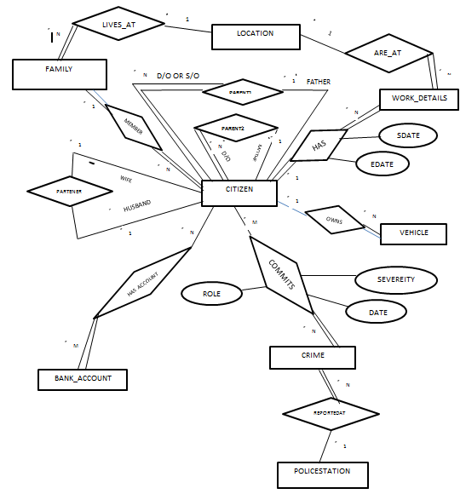

**5.4 Entity Diagrams**

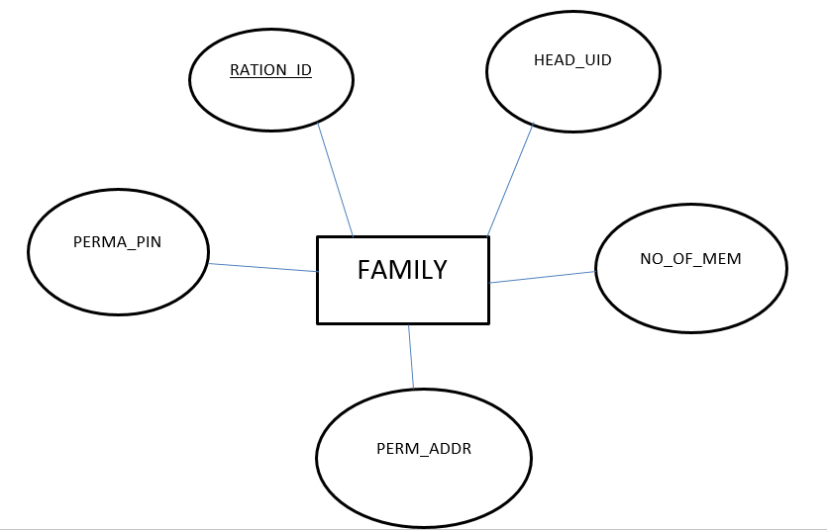

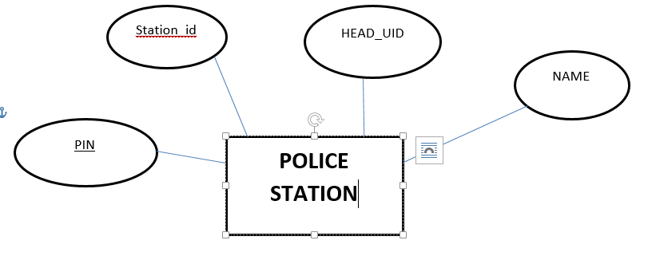

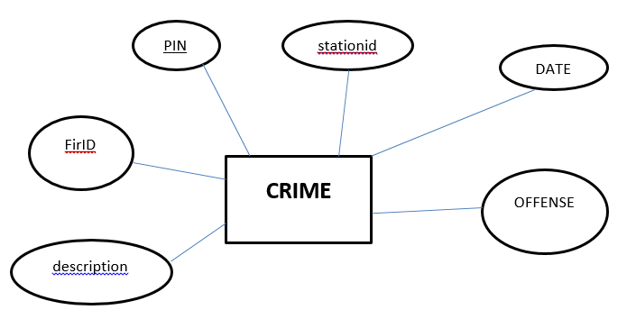

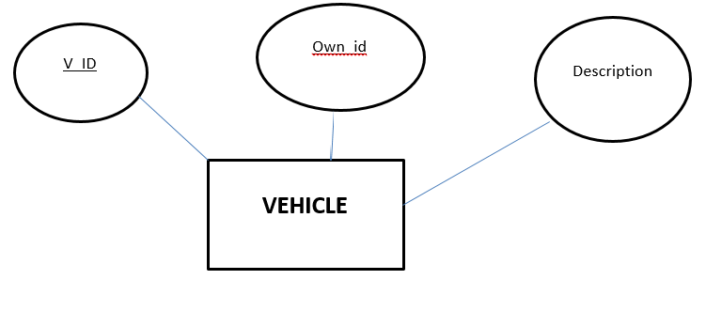

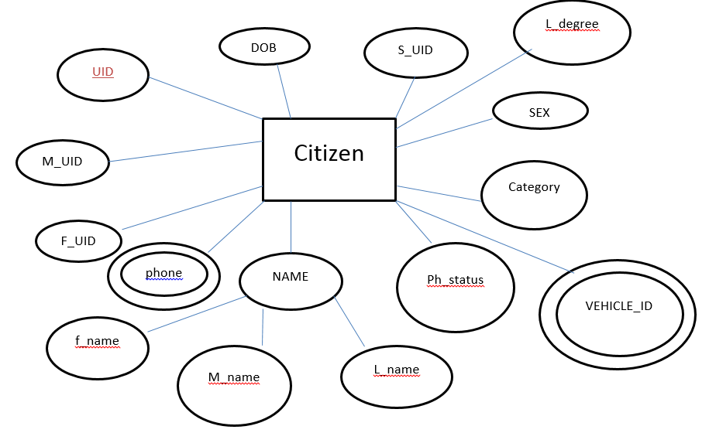

**5.5 Software Used**

NetBeans IDE 7.4 Beta

MySQL Workbench 5.2 CE

JCreator 4.50 Pro

**5.6 Design methods:**

We are going to build the front end of the application in Java framework. And going to connect the front end with SQL server database through Java Database Connection (JDBC) using the DriverManager class. The backend is handled by using the SQL library of Java and JDBC.

**CHAPTER 6**

**SCREENSHOTS**

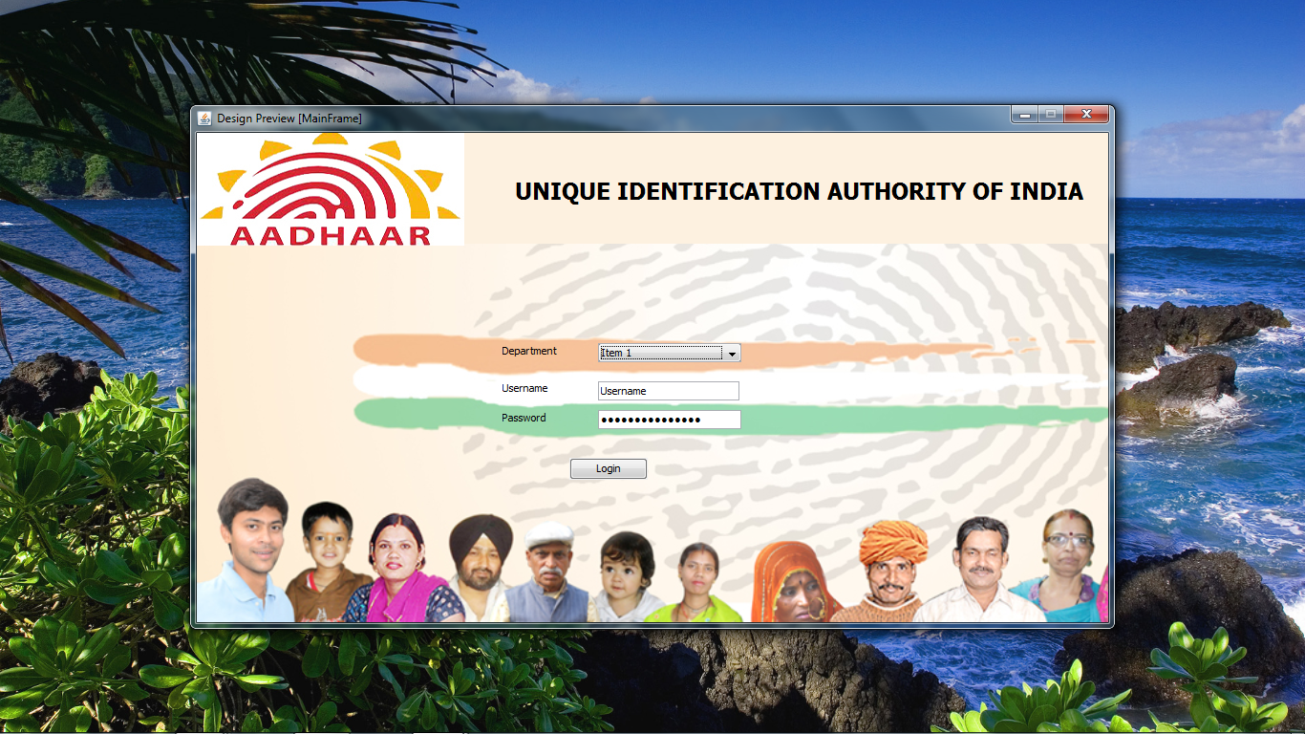

Screenshot of the login screen for authorized departments

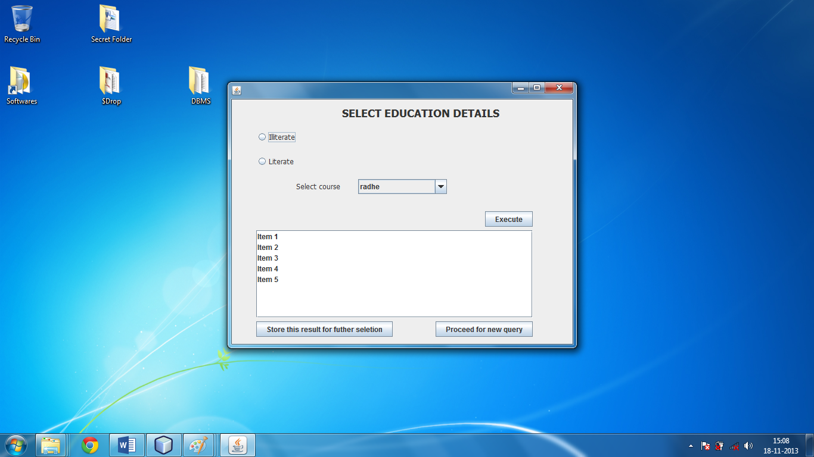

Selecting Education Details

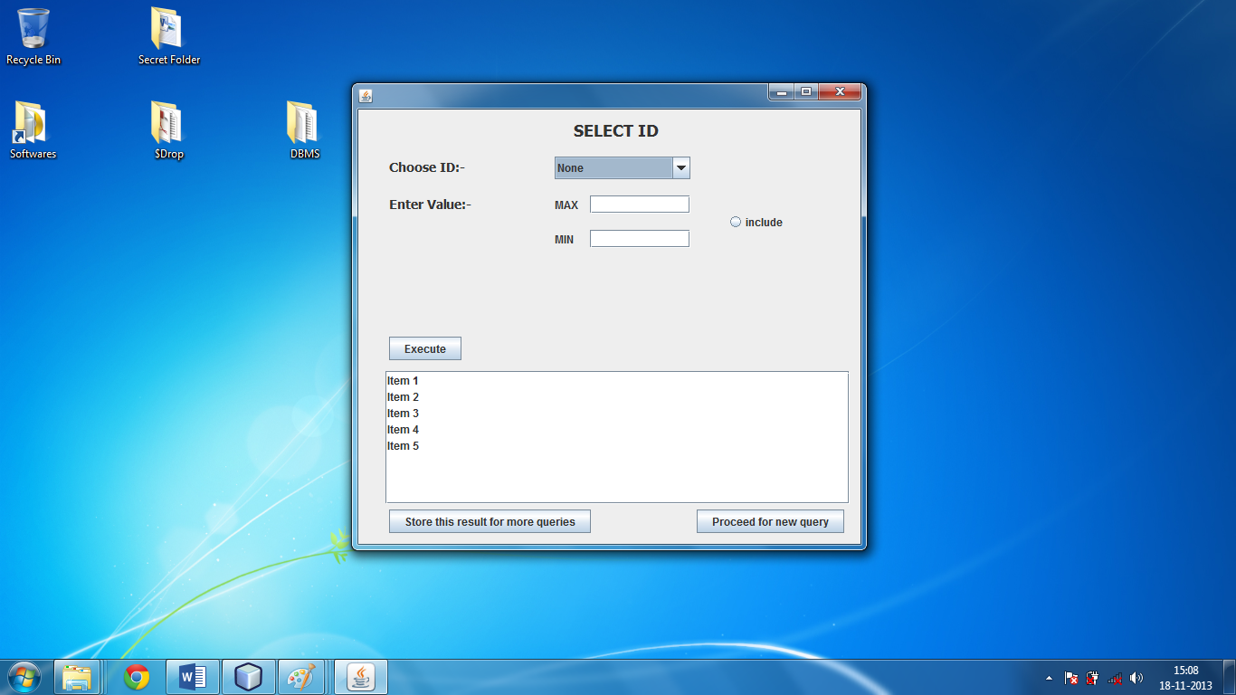

Selecting ID numbers

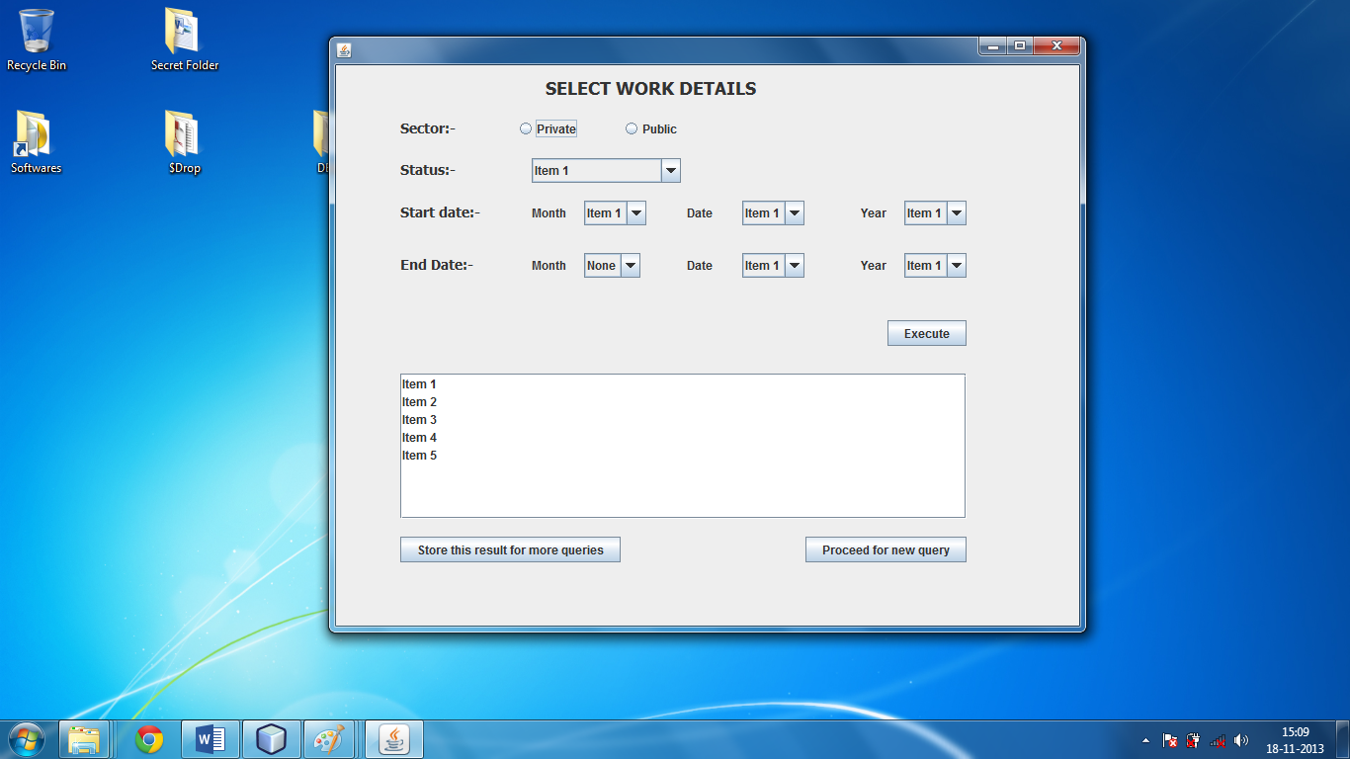

Selecting Work Details

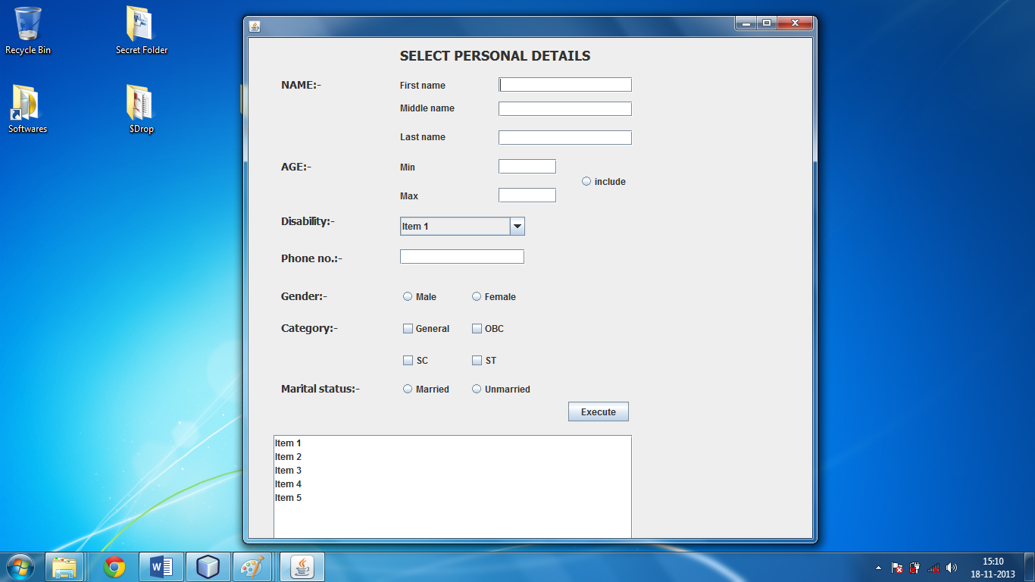

Selecting the personal details

**CHAPTER 7**

**CONCLUSION AND FUTURE SCOPE**

Although this idea seems quite simple, the scope of it is so vast that it can completely change the way our country runs and make administration more efficient. For instance, we have seen a large rise in the number of **sex offences** in the country in the past few years. This database has the facility to store these sex offenders and publish it, thus helping to prevent these crimes. Similarly, this will also help in curbing **driving offences**, accidents and deaths. We can also use this database to obtain data related to **BPL citizens, unemployment, poverty, per capita income, family details, educational details, etc**. From addressing illegal immigration and terrorist threats to curbing crimes and even handling disaster management during natural calamities, the scope of this project can be extended to almost anything. Although this idea seems quite simple, the scope of it is so vast that it can completely change the way our country runs and make administration more efficient.

**CHAPTER 8**

**REFERENCES**

[1] Fundamentals of Database Systems 6th Edition (Elmasri and Navathe)

[2][https://www.google.co.in/url?sa=t&rct=j&q=&esrc=s&source=web&cd=2&cad=rja&ved=0CDAQFjAB&url=http%3A%2F%2Fwww.karnataka.gov.in%2Fcorecommittee%2FEgov%2520Presentation%2FcitizenDB-Smartcard-Biometrics-Subcommittee- AbFmXSvQFsrCuMRAeLcA&bvm=bv.56146854,d.bmk](https://www.google.co.in/url?sa=t&rct=j&q=&esrc=s&source=web&cd=2&cad=rja&ved=0CDAQFjAB&url=http%3A%2F%2Fwww.karnataka.gov.in%2Fcorecommittee%2FEgov%2520Presentation%2FcitizenDB-Smartcard-Biometrics-Subcommittee-Summary.doc&ei=NLeBUtjQJsnDrAerwIHADA&usg=AFQjCNGigpBv4-AbFmXSvQFsrCuMRAeLcA&bvm=bv.56146854,d.bmk)

[3]<https://www.google.co.in/url?sa=t&rct=j&q=&esrc=s&source=web&cd=4&cad=rja&ved=0CDsQFjAD&url=http%3A%2F%2Fegovreach.in%2Fsocial%2Fnode%2F171&ei=NLeBUtjQJsnDrAerwIHADA&usg=AFQjCNFjkM5fVtTZeyyNGahYBlwOddRcjQ&bvm=bv.56146854,d.bmk>

[4]<https://www.google.co.in/url?sa=t&rct=j&q=&esrc=s&source=web&cd=6&cad=rja&ved=0CEYQFjAF&url=http%3A%2F%2Fwww.zdnet.com%2Findian-state-to-create-central-citizen-database-2039362480%2F&ei=NLeBUtjQJsnDrAerwIHADA&usg=AFQjCNG1A2qkBmXJpFXvHpNaRo8qLnjM7g&bvm=bv.56146854,d.bmk>

[5]<https://www.google.co.in/url?sa=t&rct=j&q=&esrc=s&source=web&cd=8&cad=rja&ved=0CFIQFjAH&url=http%3A%2F%2Fwww.karunadu.gov.in%2Fcorecommittee%2FDept%2520Presentation%2FIGR12Feb2009.doc&ei=NLeBUtjQJsnDrAerwIHADA&usg=AFQjCNGVDAKVok53tzwh9O72ZBYrak4aKw&bvm=bv.56146854,d.bmk>

[6]<https://www.google.co.in/url?sa=t&rct=j&q=&esrc=s&source=web&cd=9&cad=rja&ved=0CFcQFjAI&url=http%3A%2F%2Fwww.esri.com%2Flibrary%2Fbrochures%2Fpdfs%2Fgis-citizen-engagement.pdf&ei=NLeBUtjQJsnDrAerwIHADA&usg=AFQjCNEp-IrJHJpM_-HQOSVCyjQ&bvm=bv.56146854,d.bmk>

[7]<https://www.google.co.in/url?sa=t&rct=j&q=&esrc=s&source=web&cd=1&cad=rja&ved=0CCgQFjAA&url=http%3A%2F%2Fen.wikipedia.org%2Fwiki%2FUnique_Identification_Authority_of_India&ei=nLeBUtvtD4mxrgeLuIG4Dw&usg=AFQjCNGZCZzMXkyL2FeFgZGj6EImMf30YA&bvm=bv.56146854,d.bmk>